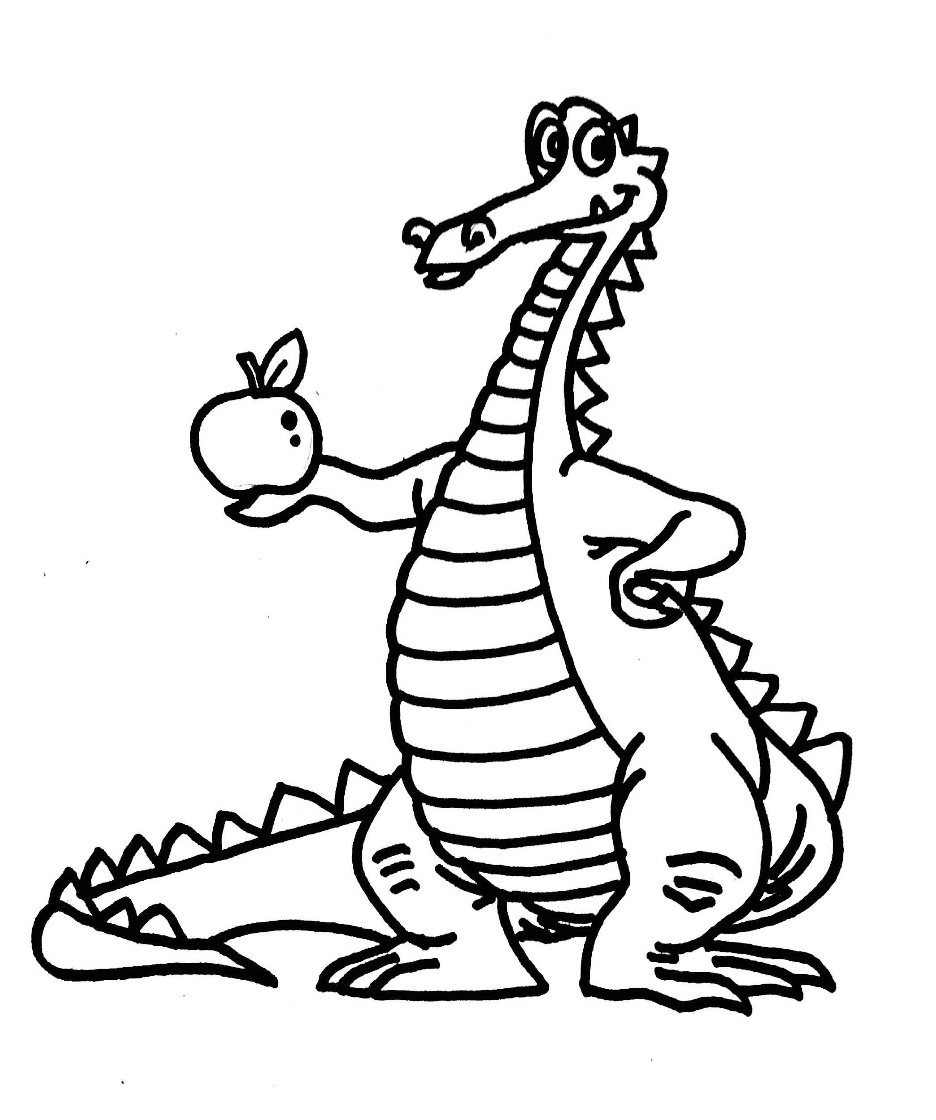 Allenwood School 2022-2023
Grade 5
Witt (Room 1)

 | Monday | Tuesday | Wednesday | Thursday | Friday
8:55-9:10am | Homeroom | Homeroom | Homeroom | Homeroom | Homeroom
9:10-9:50am  Period 1 | Art | Physical Education | Physical Education | Music | Physical Education
9:50-10:30am  Period 2 | Spanish | Technology | Band 5 | Spanish | Library
10:30-11:10am  Period 3 | Math | Math | Math | Math | Math
11:10-11:50am  Period 4 | Math | Math | Math | Math | Math
11:50am-  12:30pm  Period 5 | Science/SS | Science/SS | Science/SS | Science/SS | Science/SS
12:30-1:10pm  Period 6 | Recess/Lunch | Recess/Lunch | Recess/Lunch | Recess/Lunch | Recess/Lunch
1:10-1:50pm  Period 7 | ELA | ELA | ELA | ELA | ELA
1:50-2:30pm  Period 8 | ELA | ELA | ELA | ELA | ELA
2:30-3:10pm  Period 9 | ELA | ELA | ELA | ELA | ELA
3:10-3:20pm | Homeroom | Homeroom | Homeroom | Homeroom | Homeroom

